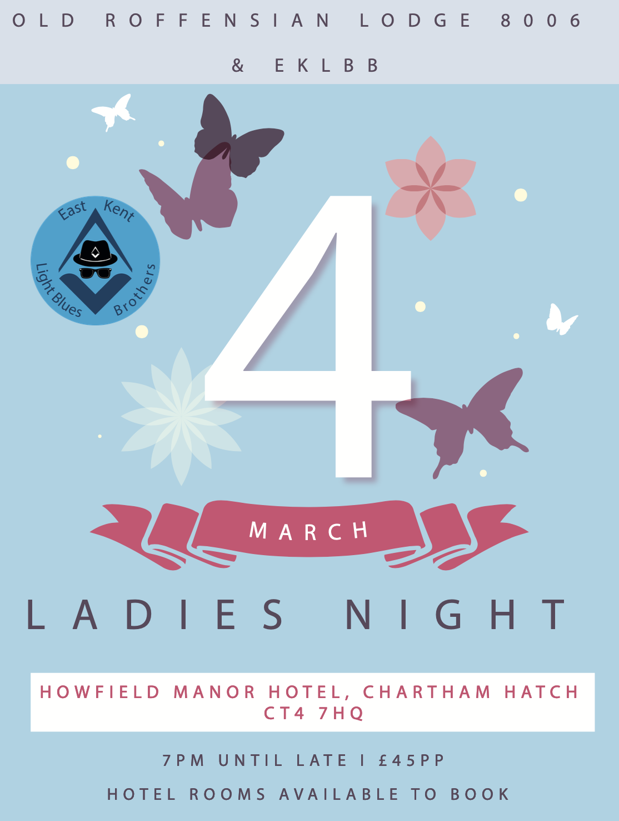

Ladies Night 2023 Menu Choices & Booking Form
Starters
- Soup of the day (v) *
- Salmon rillette with horseradish, caper and shallot dressing *
- Breaded whitebait with tartar sauce, mixed leaf salad
- Pressed ham hock terrine with mustard aioli, herb salad *
- Baked flat mushrooms with garlic and rosemary, rockette salad
(vegan) *
Mains
- Slow roasted sirloin of beef served with duck fat roasted potatoes, seasonal vegetables and Yorkshire pudding *
- Roasted loin of pork with duck fat roasted potatoes and seasonal vegetables *
- Pan fried chicken breast with truffle oil mash, wild mushrooms and
red wine sauce *
- Pearl barley risotto with butternut squash, sage and nut brown butter (v)
- Smoked haddock fishcake with mixed greens, grain mustard cream sauce
- Smoked tomato cous-cous with grilled Mediterranean vegetables, basil oil (vegan)
Desserts
- Lemon curd tart with raspberry sorbet
- Chocolate sundae with vanilla ice cream
- Vanilla crème brulee with berry compote *
- Frangipane with chantilly cream, cherry compote
- Mango and passion fruit salad (vegan) *

(*) indicates dishes that are OR can be adapted to gluten free with notification

Please Add Meal Choice Numbers Below
Name & Masonic Rank if applicable | Starter | Main | Dessert

Closing Date For Bookings: 11th February 2023

Payment Details: £45 per person
Cheque: Payable to Andrew Berry and post to 55 Downs Avenue, Whitstable, CT5 1RR
BACS: Lloyds Bank, Sort Code 30-94-47, Account No. 48960260, Account name Andrew Berry
Payment Ref: Your Name
To book a room for the evening please contact Howfield Manor directly and inform them of your attendance at the Masonic function.
Address: Howfield Manor, Howfield Lane, Chartham Hatch, Canterbury, CT4 7HQ

Phone: 01227 733892

Email: hotel@howfield.net

Website: www.HowfieldCanterbury.co.uk

